**ECE 254 Homework 1**

**Matched Filter**

**Name: Mingxuan Wang**

**Date: 2015/10/4**

* Title: Matched Filter
* 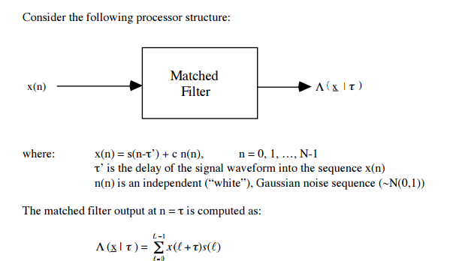Objective:

1. Define the following 4 signal waveforms:
2. Short Tone Ping(L = 16)
3. Long Tone Ping(L = 128)
4. FM Ping(L =128)
5. Pseudo-Random Noise Ping(L = 128)
6. Determine the value of c such that SNR satisfies:

Infinite dB, 0 dB, -6 dB

1. Generate sequence x(n) of length N = 512 with τ’ = 128. Plot time series for the following:
2. X(n), n = 0….385

$Λ\left(x | τ\right), n=0……385$

* Approach:

1. For the first problem, we can easily generate 4 signal waveforms using Matlab with their definition.

Notice that for Short Tone Ping, L is 16 and for the rest three signal waveforms, L is 128.

For Pseudo-Random Noise (PRN) Ping, I first generate a random series with 0 mean and 1 variance Gaussian distribution. Using this random series, I can make Aj = 1 when it is over 0 and Aj = -1 otherwise. Finally I generate the result as figure 1.

1. According to $SNR= \frac{A^{2}}{2σ^{2}}= \frac{1}{2σ^{2 }}= \frac{1}{2c^{2}}$ and dB = 10 $\log_{10}SNR$, we can easily compute c.

c1 = 0 when dB is infinite

c2 = $\frac{\sqrt{2}}{2}$ when dB is 0

c3 = $\frac{\sqrt{{10}^{0.6}}}{\sqrt{2}}$ when dB is -6

1. There are two equation in this problem
2. For the first one, shift the signal along time axis to right with 128 points. And then add Gaussian noise to it.
3. For the second one, we use loops to calculate lambda, which is cross correlation.

* Result (with plots)

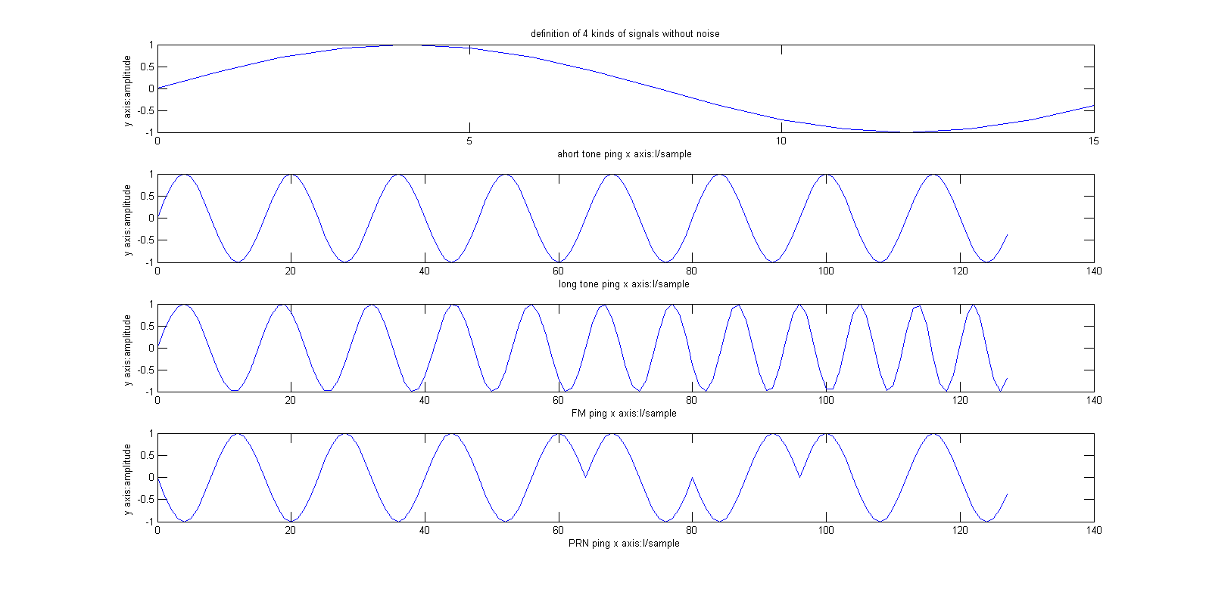1.

Figure 1. Four signal waveforms

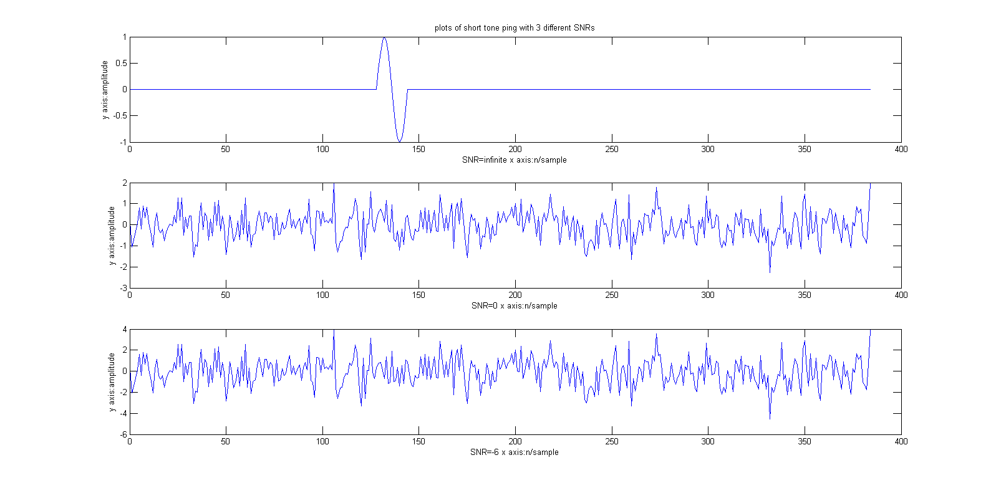 3A.

Figure 2. Short tone ping with 3 different SNRs

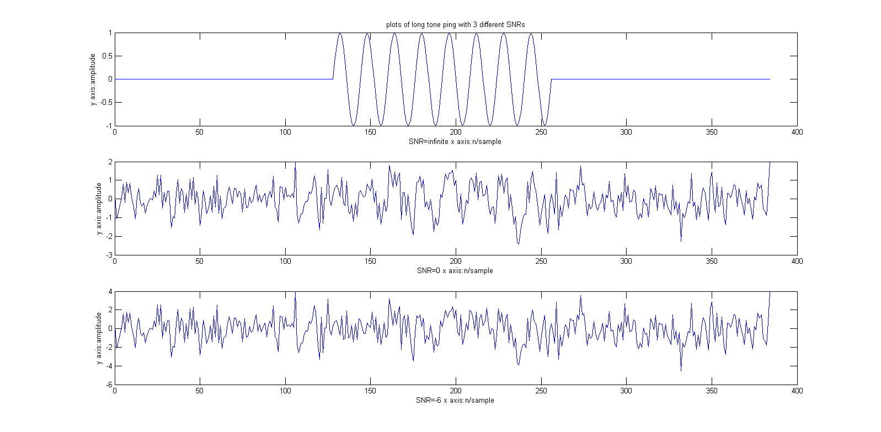

Figure 3. Long tone ping with 3 different SNRs

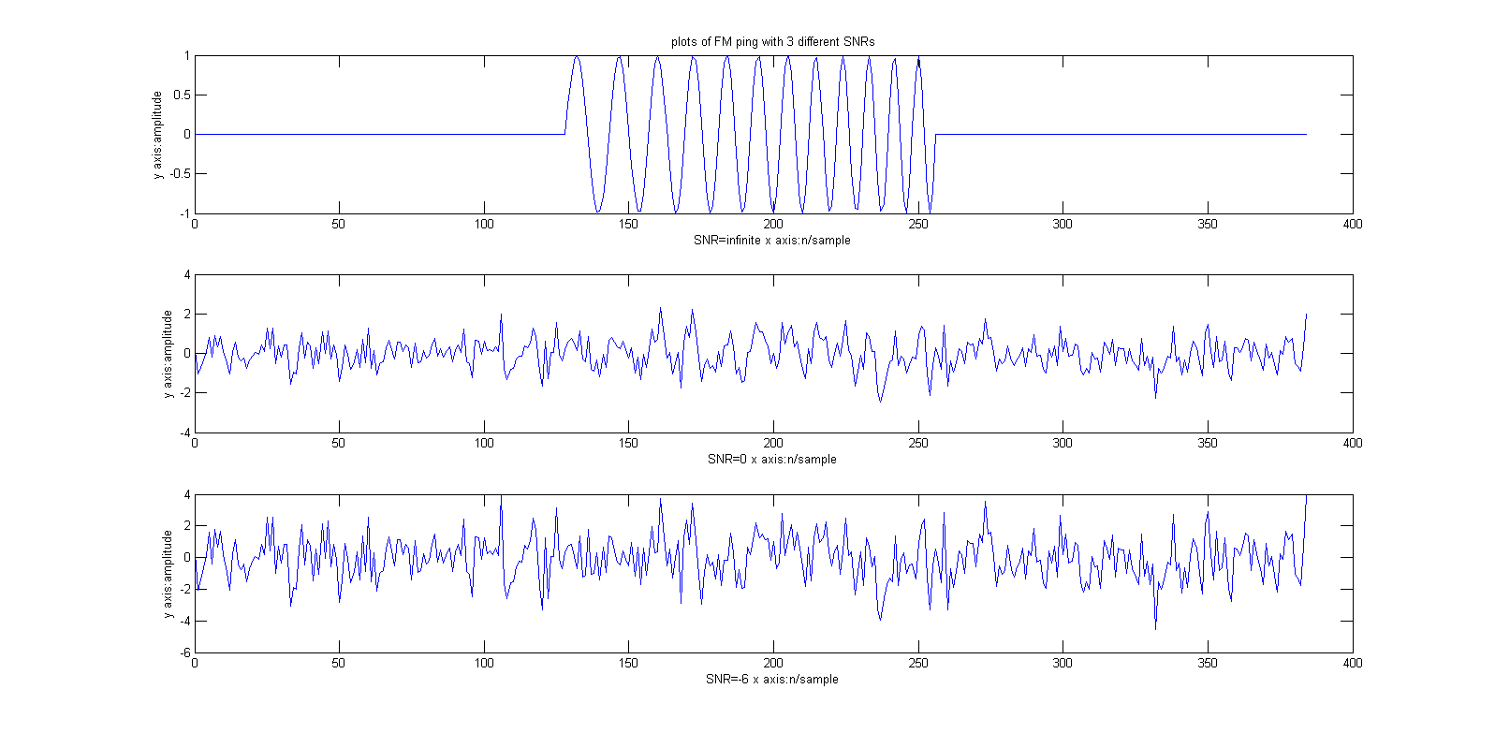

Figure 4. FM ping with 3 different SNRs

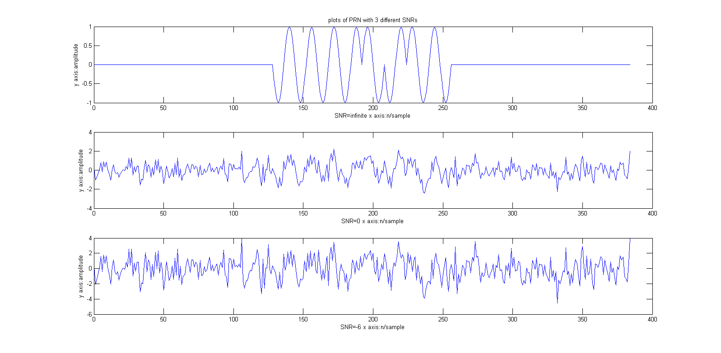

Figure 5. PRN ping with 3 different SNRs

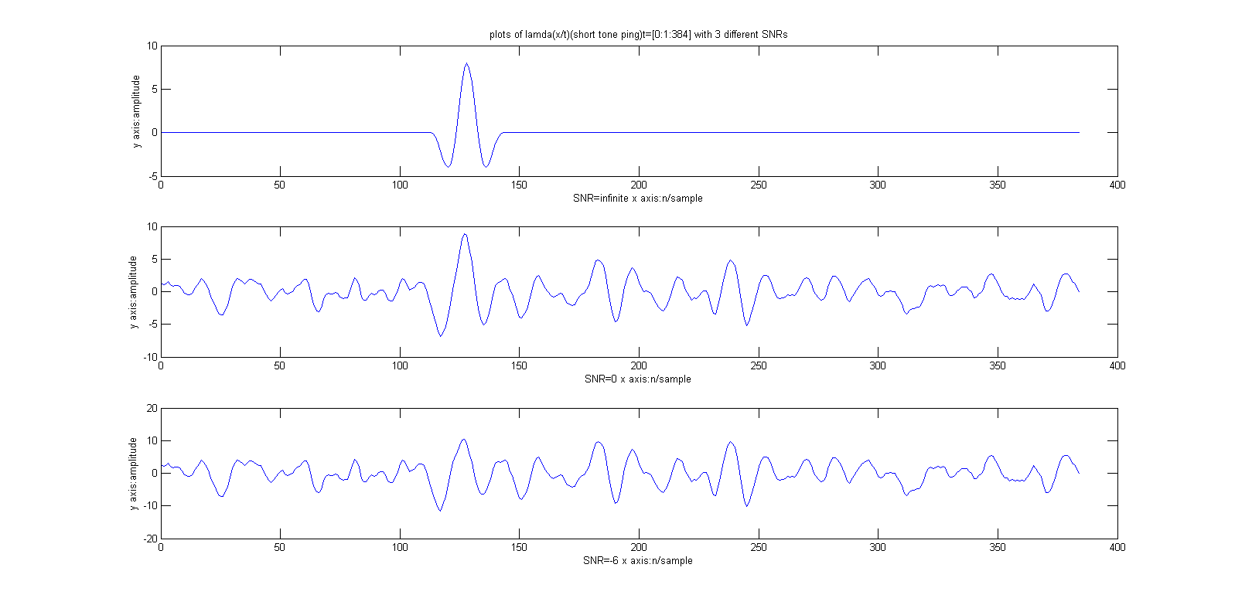3B.

Figure 6. Lambda of short tone ping with 3 different SNRs

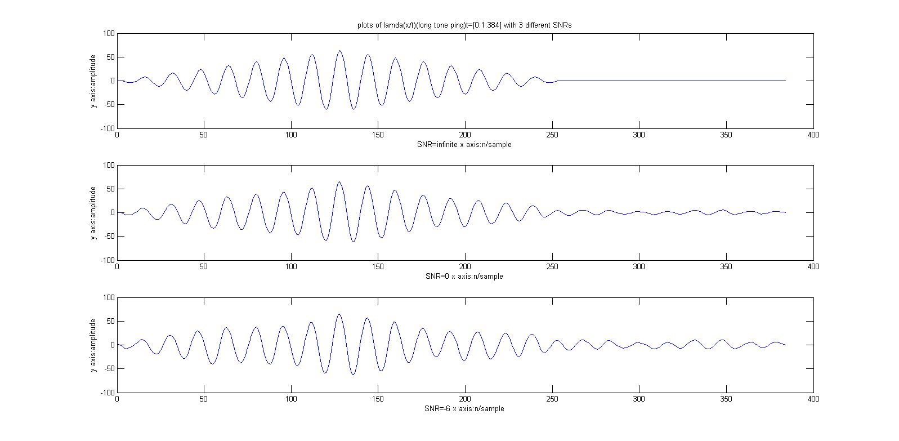

Figure 7. Lambda of long tone ping with 3 different SNRs

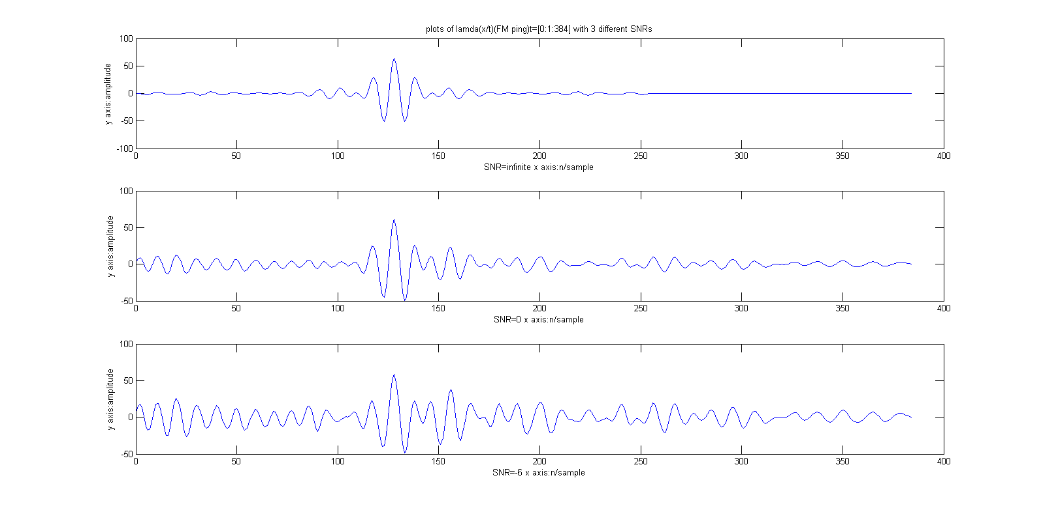

Figure 8. Lambda of FM ping with 3 different SNRs

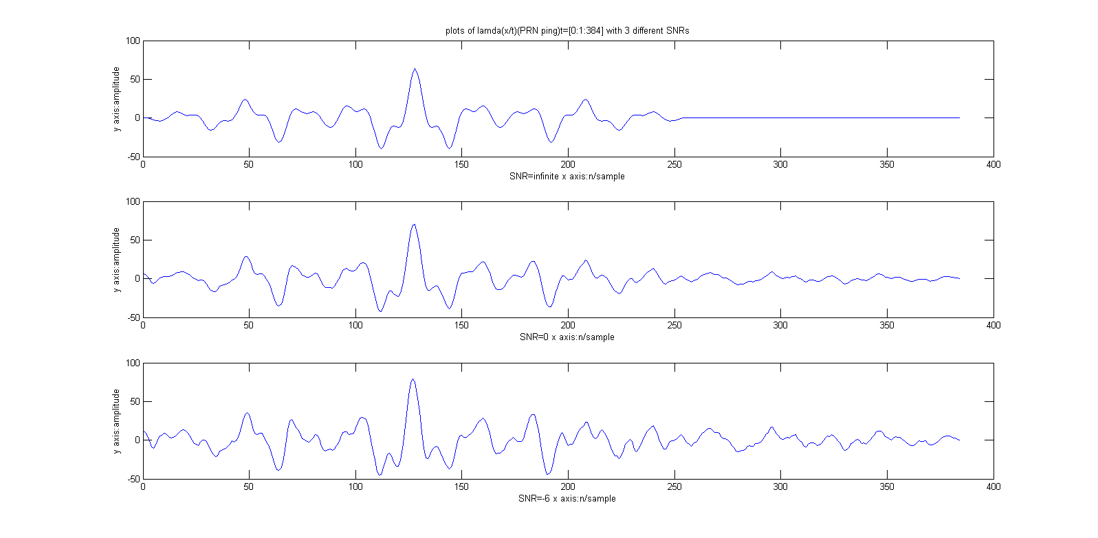

Figure 9. Lambda of PRN ping with 3 different SNRs

* Summary(Discussion)

1. In figure 1, there are four waveforms corresponding to four kinds of signals. The first three are sinusoid waveforms with different frequency. The last one, PRN Ping, is also sinusoid with variant coefficient of amplitude.
2. From figure 2 to figure 5:

x(n) is just 128 points shifted right of s(n) and it is clearly sinusoid.

When we get larger c, this means the value of SNR is smaller. The waveform has more noise.

1. From figure 6 to figure 9:

Each of the figure contains 3 plots which are with different SNRs. We can figure out from these plots that when t gets to be near 128, which is the delay of sn, the result becomes larger than others. This is due to the result is the cross correlation of xn and sn.

Like above, when the value of SNRs becomes smaller, the influence of noise becomes bigger and we cannot ignore it. At last, we even cannot recognize the signal.

Another thing is long tone ping is easier to be detected than short tone ping due to more waveform energy.

* Appendix(code)

%% p1: define the following signal waveforms

% define constance

fc = 1/16;

l_short = 0:15;

l_long = 0:127;

f_prime = 1/(16*128);

% Short Tone Ping

Sstp = sin(2*pi*fc*l_short);

% Lont Tone Ping

Sltp = sin(2*pi*fc*l_long);

% FM Ping

Sfmp = sin(2*pi*(fc+l_long*f_prime/2).*l_long);

% Pseudo-Random Noise (PRN) Ping

rd = randn(1, 8);

Aj = ones(1, 8);

Sprnp = ones(1, 8);

for j = 1:1:8

if rd(j) > 0

Aj(j) = 1;

else

Aj(j) = -1;

end

end

for j = 0:1:7

for l = 0:1:15

Sprnp(l+1+j*16) = Aj(j+1)*sin(2*pi*fc*(l+j*16));

end

end

%% plot for each signal waveform

figure(1)

subplot(4,1,1)

plot(l_short,Sstp)

xlabel('hort tone ping x axis:l/sample')

ylabel('y axis:amplitude ')

title('definition of 4 kinds of signals without noise')

subplot(4,1,2)

plot(l_long,Sltp)

xlabel('long tone ping x axis:l/sample')

ylabel('y axis:amplitude ')

subplot(4,1,3)

plot(l_long,Sfmp)

xlabel('FM ping x axis:l/sample')

ylabel('y axis:amplitude ')

subplot(4,1,4)

plot(l_long,Sprnp)

xlabel('PRN ping x axis:l/sample')

ylabel('y axis:amplitude ')

%% p3A

% define constance

N = 0:511;

tau = 128;

nn = randn(1, 385);

c1 = 0;

c2 = 2^(1/2)/2;

c3 = (10^0.6/2)^(1/2);

n = 0:384;

n_number = 385;

% Short Tone Ping

Sstp = [zeros(1,tau), Sstp, zeros(1, n_number-tau-16)];

Xstp1 = Sstp; %infinite db

Xstp2 = Sstp+c2*nn; %0db

Xstp3 = Sstp+c3*nn; %-6db

figure(2)

subplot(3,1,1)

plot(n,Xstp1)

title('plots of short tone ping with 3 different SNRs')

xlabel('SNR=infinite x axis:n/sample')

ylabel('y axis:amplitude')

subplot(3,1,2)

plot(n,Xstp2)

xlabel('SNR=0 x axis:n/sample')

ylabel('y axis:amplitude')

subplot(3,1,3)

plot(n,Xstp3)

xlabel('SNR=-6 x axis:n/sample')

ylabel('y axis:amplitude')

% Long Tone Ping

Sltp = [zeros(1,tau), Sltp, zeros(1, n_number-tau-128)];

Xltp1 = Sltp; %infinite db

Xltp2 = Sltp + c2*nn; %0db

Xltp3 = Sltp + c3*nn; %-6db

figure(3)

subplot(3,1,1)

plot(n,Xltp1)

title('plots of long tone ping with 3 different SNRs')

xlabel('SNR=infinite x axis:n/sample')

ylabel('y axis:amplitude')

subplot(3,1,2)

plot(n,Xltp2)

xlabel('SNR=0 x axis:n/sample')

ylabel('y axis:amplitude')

subplot(3,1,3)

plot(n,Xltp3)

xlabel('SNR=-6 x axis:n/sample')

ylabel('y axis:amplitude')

% FM Ping

Sfmp = [zeros(1,tau), Sfmp, zeros(1, n_number-tau-128)];

Xfmp1 = Sfmp;

Xfmp2 = Sfmp+c2*nn;

Xfmp3 = Sfmp+c3*nn;

figure(4)

subplot(3,1,1)

plot(n,Xfmp1)

title('plots of FM ping with 3 different SNRs')

xlabel('SNR=infinite x axis:n/sample')

ylabel('y axis:amplitude')

subplot(3,1,2)

plot(n,Xfmp2)

xlabel('SNR=0 x axis:n/sample')

ylabel('y axis:amplitude')

subplot(3,1,3)

plot(n,Xfmp3)

xlabel('SNR=-6 x axis:n/sample')

ylabel('y axis:amplitude')

% Pseudo-Random Noise Ping

Sprnp = [zeros(1,tau), Sprnp, zeros(1, n_number-tau-128)];

Xprnp1 = Sprnp;

Xprnp2 = Sprnp + c2*nn;

Xprnp3 = Sprnp + c3*nn;

figure(5)

subplot(3,1,1)

plot(n,Xprnp1)

title('plots of PRN with 3 different SNRs')

xlabel('SNR=infinite x axis:n/sample')

ylabel('y axis:amplitude')

subplot(3,1,2)

plot(n,Xprnp2)

xlabel('SNR=0 x axis:n/sample')

ylabel('y axis:amplitude')

subplot(3,1,3)

plot(n,Xprnp3)

xlabel('SNR=-6 x axis:n/sample')

ylabel('y axis:amplitude')

%% p3B

%short tone ping

lamdastp1=zeros(1, n_number);

lamdastp2=zeros(1, n_number);

lamdastp3=zeros(1, n_number);

Xstp1=[Sstp, zeros(1,16)]; %infinte db

Xstp2=[Sstp+c2*nn, zeros(1,16)]; %0 db

Xstp3=[Sstp+c3*nn, zeros(1,16)]; %-6 db

for t=0:1:n_number-1

s1=0;

s2=0;

s3=0;

for l=0:1:15

temp1=Xstp1(l+t+1)*Sstp(l+1+tau);

s1=s1+temp1;

lamdastp1(t+1)=s1;

temp2=Xstp2(l+t+1)*Sstp(l+1+tau);

s2=s2+temp2;

lamdastp2(t+1)=s2;

temp3=Xstp3(l+t+1)*Sstp(l+1+tau);

s3=s3+temp3;

lamdastp3(t+1)=s3;

end

end

figure(6)

subplot(3,1,1)

plot(n,lamdastp1)

title('plots of lamda(x/t)(short tone ping)t=[0:1:384] with 3 different SNRs')

xlabel('SNR=infinite x axis:n/sample')

ylabel('y axis:amplitude')

subplot(3,1,2)

plot(n,lamdastp2)

xlabel('SNR=0 x axis:n/sample')

ylabel('y axis:amplitude')

subplot(3,1,3)

plot(n,lamdastp3)

xlabel('SNR=-6 x axis:n/sample')

ylabel('y axis:amplitude')

% Long Tone Ping

lamdaltp1=zeros(1, n_number);

lamdaltp2=zeros(1, n_number);

lamdaltp3=zeros(1, n_number);

Xltp1=[Sltp, zeros(1,128)]; %infinte db

Xltp2=[Sltp+c2*nn, zeros(1,128)]; %0 db

Xltp3=[Sltp+c3*nn, zeros(1,128)]; %-6 db

for t=0:1:n_number-1

s1=0;

s2=0;

s3=0;

for l=0:1:127

temp1=Xltp1(l+t+1)*Sltp(l+1+tau);

s1=s1+temp1;

lamdaltp1(t+1)=s1;

temp2=Xltp2(l+t+1)*Sltp(l+1+tau);

s2=s2+temp2;

lamdaltp2(t+1)=s2;

temp3=Xltp3(l+t+1)*Sltp(l+1+tau);

s3=s3+temp3;

lamdaltp3(t+1)=s3;

end

end

figure(7)

subplot(3,1,1)

plot(n,lamdaltp1)

title('plots of lamda(x/t)(long tone ping)t=[0:1:384] with 3 different SNRs')

xlabel('SNR=infinite x axis:n/sample')

ylabel('y axis:amplitude')

subplot(3,1,2)

plot(n,lamdaltp2)

xlabel('SNR=0 x axis:n/sample')

ylabel('y axis:amplitude')

subplot(3,1,3)

plot(n,lamdaltp3)

xlabel('SNR=-6 x axis:n/sample')

ylabel('y axis:amplitude')

% FM Ping

lamdafmp1=zeros(1, n_number);

lamdafmp2=zeros(1, n_number);

lamdafmp3=zeros(1, n_number);

Xfmp1=[Sfmp, zeros(1,128)]; %infinte db

Xfmp2=[Sfmp+c2*nn, zeros(1,128)]; %0 db

Xfmp3=[Sfmp+c3*nn, zeros(1,128)]; %-6 db

for t=0:1:n_number-1

s1=0;

s2=0;

s3=0;

for l=0:1:127

temp1=Xfmp1(l+t+1)*Sfmp(l+1+tau);

s1=s1+temp1;

lamdafmp1(t+1)=s1;

temp2=Xfmp2(l+t+1)*Sfmp(l+1+tau);

s2=s2+temp2;

lamdafmp2(t+1)=s2;

temp3=Xfmp3(l+t+1)*Sfmp(l+1+tau);

s3=s3+temp3;

lamdafmp3(t+1)=s3;

end

end

figure(8)

subplot(3,1,1)

plot(n,lamdafmp1)

title('plots of lamda(x/t)(FM ping)t=[0:1:384] with 3 different SNRs')

xlabel('SNR=infinite x axis:n/sample')

ylabel('y axis:amplitude')

subplot(3,1,2)

plot(n,lamdafmp2)

xlabel('SNR=0 x axis:n/sample')

ylabel('y axis:amplitude')

subplot(3,1,3)

plot(n,lamdafmp3)

xlabel('SNR=-6 x axis:n/sample')

ylabel('y axis:amplitude')

% Pseudo Random Noise Ping

lamdaprnp1=zeros(1, n_number);

lamdaprnp2=zeros(1, n_number);

lamdaprnp3=zeros(1, n_number);

Xprnp1=[Sprnp, zeros(1,128)]; %infinte db

Xprnp2=[Sprnp+c2*nn, zeros(1,128)]; %0 db

Xprnp3=[Sprnp+c3*nn, zeros(1,128)]; %-6 db

for t=0:1:n_number-1

s1=0;

s2=0;

s3=0;

for l=0:1:127

temp1=Xprnp1(l+t+1)*Sprnp(l+1+tau);

s1=s1+temp1;

lamdaprnp1(t+1)=s1;

temp2=Xprnp2(l+t+1)*Sprnp(l+1+tau);

s2=s2+temp2;

lamdaprnp2(t+1)=s2;

temp3=Xprnp3(l+t+1)*Sprnp(l+1+tau);

s3=s3+temp3;

lamdaprnp3(t+1)=s3;

end

end

figure(9)

subplot(3,1,1)

plot(n,lamdaprnp1)

title('plots of lamda(x/t)(PRN ping)t=[0:1:384] with 3 different SNRs')

xlabel('SNR=infinite x axis:n/sample')

ylabel('y axis:amplitude')

subplot(3,1,2)

plot(n,lamdaprnp2)

xlabel('SNR=0 x axis:n/sample')

ylabel('y axis:amplitude')

subplot(3,1,3)

plot(n,lamdaprnp3)

xlabel('SNR=-6 x axis:n/sample')

ylabel('y axis:amplitude')